Reflective Synthesis Paper: AI Career Pathway and Labor Market Intelligence Platform

Zhirui Wang
Udacity Master of AI
Integrative Industry Sysnthesis
3/6/2026

Industry Context and Problem Definition
The industry focus is Workforce Development / HR Technology / Education Technology. Workers often lack clear visibility into viable career transitions, including which skills to develop, potential salary trade-offs, and exposure to automation risk; employers and policymakers lack robust insights into transition feasibility, equity-informed workforce intelligence, and forward-looking skill-gap forecasting. Existing job platforms typically offer generic recommendations rather than evidence-based, personalized career pathways. This project addresses that gap by designing a decision-support system that integrates labor market statistics, predictive modeling, skill-based recommendation, and narrative roadmap generation into a single pipeline.
The problem is appropriate for AI because it involves large-scale labor market data (statistical and analytical methods), skill similarity and ranking (machine learning and recommender techniques), and personalized roadmaps (generative AI and agentic workflows). Labor market projections and skill demand are increasingly data-driven; integrating multiple AI paradigms allows the system to quantify opportunity, predict feasibility, recommend next steps, and communicate outcomes in accessible form. The system is intended to support, not replace, human judgment; all outputs are framed as decision support with explicit limitations. Constraints include reliance on static or periodic data (e.g., BLS, O*NET) rather than real-time job postings; transition recommendations may be derived from heuristics; historical labor market inequities can be reflected in models; and labor market dynamics are inherently uncertain. Transparency is important so that workers and employers can assess the validity of recommendations.
Overview of the Integrated Solution
The integrated artifact is an AI Career Pathway and Labor Market Intelligence Platform: a Streamlit application where users enter their current occupation in natural language, optionally refine with skills or preferences, and receive ranked career transitions plus a 6–12 month narrative roadmap. Under the hood, a reproducible data pipeline (O*NET and BLS) builds the occupation dataset; a labor market statistical engine supplies growth and salary metrics; TF-IDF–based skill similarity and a weighted recommender rank transitions and identify skill gaps; and two ADK agents—an occupation matcher and a roadmap generator—resolve natural-language input and produce the final report. The solution combines methods from four prior capstones (data workflow, statistics, ML/recommender, agentic AI) into one runnable pipeline with documented architecture and limitations.
Integration of Prior Projects and Methods
The integration plan draws on at least three prior capstone projects as required; this project integrates four prior capstone domains in code (1, 2, 3, 6).
Capstone 1 (AI Programming Foundations) contributes a reproducible data workflow: the O*NET and BLS data pipeline that fetches, merges, and writes occupation data. Versioned inputs, deterministic merge, and documented steps support reproducibility.
Capstone 2 (Statistical Analysis) contributes labor market analysis: salary distributions, growth trends, and risk-adjusted opportunity scores. These outputs provide features and filters for downstream components and define what “high-value” targets mean in the pipeline.
Capstone 3 (Applied ML) contributes skill similarity via TF-IDF and cosine similarity over occupation text (title, skills, abilities, knowledge, work activities, interests) and a recommender that scores each candidate transition as 0.8×overlap + 0.1×growth + 0.1×salary (normalized), ranks transitions, and extracts skill, knowledge, and ability gaps. It consumes statistical outputs and ranks feasible transitions.
Capstone 6 (Agentic AI) contributes a multi-agent system: (1) Occupation matcher agent—resolves natural-language occupation via a tool; (2) Roadmap generator agent—uses a tool to get current role and top-transition context, then produces the markdown roadmap. This demonstrates agentic orchestration with tools.
The components interact in sequence: data pipeline → occupation dataset → user profile → occupation matcher agent → statistical engine → skill similarity and recommender → roadmap generator agent → final report. This integration plan guided the system design and implementation and ensures that the artifact is a single pipeline with defined handoffs between domains.
Technical Design Decisions (and Tradeoffs)
The system is designed as a modular pipeline and a decision-support system that does not replace human judgment. The statistical engine computes per-occupation growth scores, approximate salary percentiles, and risk-adjusted opportunity metrics. The recommender builds a skill similarity matrix (TF-IDF + cosine) and scores each candidate as 0.8×overlap + 0.1×growth + 0.1×salary (normalized), ranks transitions, and extracts skill, knowledge, and ability gaps. The multi-agent module (occupation matcher agent and roadmap generator agent) produces the selected occupation and the final roadmap text; the roadmap agent uses a tool to get context and writes the markdown.
Key technical decisions include: (1) TF-IDF and cosine similarity for skill similarity to avoid dependency on external embedding APIs while demonstrating recommender-style reasoning; (2) ADK agents for both occupation matching and roadmap generation. The architecture diagram below illustrates the end-to-end flow, from user input through each component to the final report generation.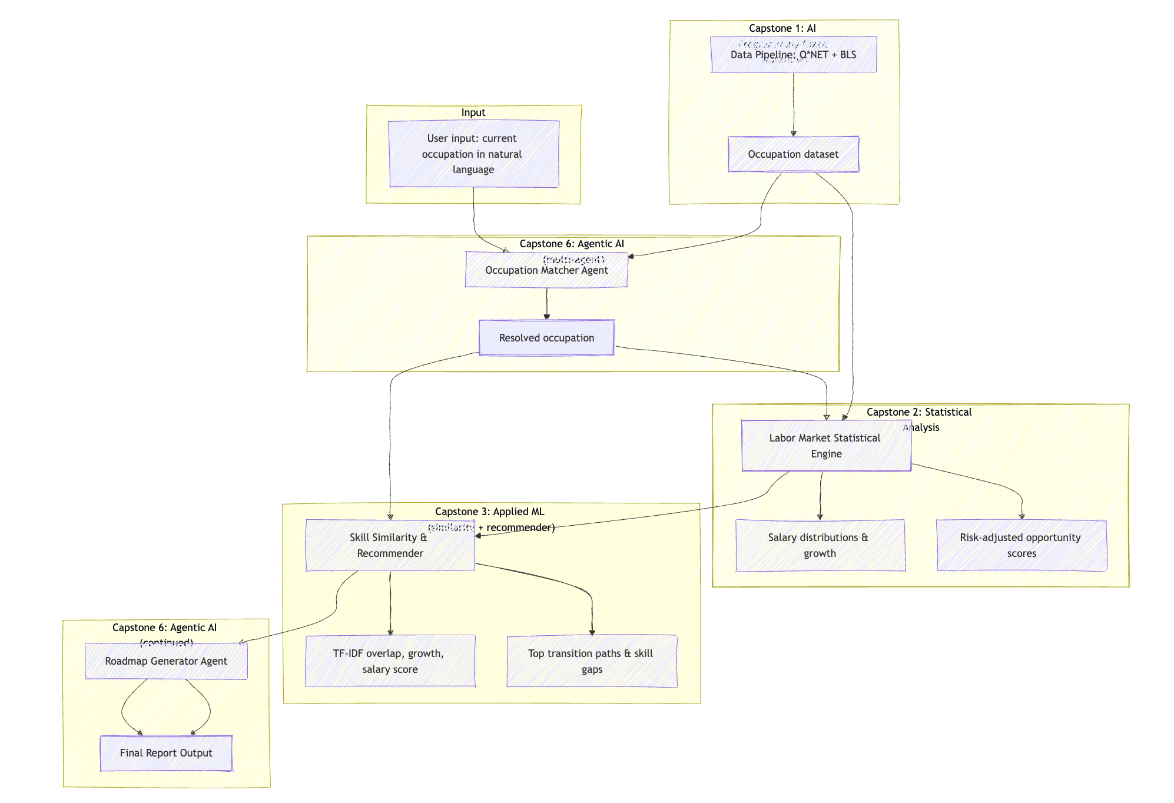
Assumptions: Occupation and skill data are available (e.g., BLS, O*NET). Transition “success” can be approximated by heuristics. Users understand that outputs are decision support, not guarantees. One pipeline run is sufficient for a single user profile; real-time streaming is out of scope.
Design tradeoffs: Simplicity vs. realism—manageable set of occupations and heuristics transition labels to keep the artifact runnable; real deployment would use richer data and labels. Interpretability vs. performance—interpretable models (TF-IDF, cosine similarity) where possible; document tradeoffs if moving to more complex models. Static data vs. dynamic market—design accepts static snapshots; extensions could add periodic data refresh.
Boundaries: In scope—integrated analysis and recommendation for demonstration; clear documentation of data sources and limitations. Out of scope—real-time job posting ingestion, legal or financial advice, guarantees of employment or salary outcomes. The system does not make decisions for the user; it supports them.
Ethical, Governance, and Responsible AI Considerations
At least one ethical concern is addressed in depth, grounded in the industry and system design. Bias and fairness are salient: labor market data and historical hiring patterns can encode gender, racial, or educational inequities (O’Neil, 2016). If the transition model or recommender is trained or calibrated on such data without auditing, outputs can reinforce existing disparities or steer underrepresented groups toward lower-growth or lower-pay paths. Transparency and overconfidence also matter: users might treat transition probabilities as guarantees rather than estimates, leading to overreliance on the system. Accountability is addressed by framing the system as decision support and including explicit disclaimers and limitation text in the generated roadmap.
Safeguards and responsible deployment reasoning include: (1) stating clearly that the system is for support, not replacement, of human decisions; (2) reporting uncertainty (e.g., “model-based probability”) in the roadmap; (3) recommending bias auditing (e.g., disaggregated performance and recommendation rates by demographic groups) before real-world use; (4) documenting data sources and heuristics assumptions so stakeholders can assess validity.
Governance considerations for real-world use would include defining who is accountable for incorrect or harmful recommendations, how often models are retrained or audited, and how user feedback is incorporated. A further ethical concern is automation displacement: recommending transitions into roles that may themselves be at higher automation risk could mislead users; the roadmap and documentation surface limitations so users can interpret recommendations in context.
Evaluation and Reflection
The integrated system was evaluated against its intended goals. It successfully produces labor market metrics (growth, salary, risk-adjusted scores) per occupation; ranks transitions by a combined score (profile overlap 80%, growth 10%, salary 10%) and identifies skill, knowledge, and ability gaps; and generates a structured, human-readable career roadmap via the roadmap generator agent.
Strengths: Coherent integration of statistics, skill similarity (TF-IDF), recommender, and multi-agent system (occupation matcher + roadmap generator) in a single pipeline; observable outputs via the Streamlit app (full report, ranked transition table with gaps); reproducibility (deterministic logic, requirements.txt, clear modules); interpretability (profile overlap, growth, salary delta, skill/knowledge/ability gaps exposed; roadmap explains limitations).
Tradeoffs assessed: TF-IDF and a simple weighted score were chosen so the pipeline runs quickly and remains interpretable; more complex models could improve accuracy at the cost of explainability. Using a small sample keeps the artifact deliverable; production would require larger datasets and validation. Outputs are framed as decision support, with explicit disclaimers and risk/limitation text in the roadmap.
How evaluation was conducted: Qualitative—manual inspection of roadmap content and ranking coherence (e.g., Web Developer → Computer and Information Research Scientists as a top transition). Execution—run the streamlit app to verify end-to-end outputs.
Reflection: The capstone reinforced that system-level design—clear data flow, component boundaries, and documentation—is as important as individual model choice. The sequential pipeline allowed each prior capstone’s methods to contribute a well-defined output; the combination of profile overlap, growth, and salary into a single ranking score produced coherent recommendations.
Limitations and Risks
Transition "success" is heuristic-based (skill overlap + salary delta); real deployment could use labeled transition data and a trained model. The occupation set is from an O*NET/BLS snapshot; there is no real-time BLS or job-posting integration. If historical data encode wage gaps or underrepresentation, model outputs can perpetuate inequities. Users may over-rely on probabilities if interpreted as guarantees. The system does not provide legal or financial advice or employment outcomes; it is decision support only.
Professional and Industry Relevance
This project demonstrates readiness for advanced industry or research roles by connecting technical capability, ethical judgment, and professional communication. It shows the ability to synthesize data analysis, ML, recommender, and agentic components into a single coherent system; to justify design choices with reference to prior project work and constraints; to address ethical and responsible-AI considerations in a domain-specific way; and to document the system so that architecture, component interaction, and limitations are clear. The artifact and paper together form a capstone-level portfolio piece that illustrates system-level thinking, cross-domain fluency, and industry relevance to workforce development and HR tech. The artifact is documented with an architecture diagram, a README, modular source code, and a requirements file so that reviewers and employers can understand and reproduce the system.
Future Extensions or Improvements

Future work could include: integration with live labor market APIs; fairness audits (disaggregated metrics by demographic groups) and user studies to validate recommendation quality and perceived usefulness; replacing heuristic transition labels with real outcomes data where available; scaling to a larger occupation taxonomy; optional LLM-based roadmap generation with appropriate guardrails; and periodic retraining and versioning of the ML and recommender components as new data arrive. Formal quantitative evaluation (e.g., AUC on held-out transition pairs) would strengthen claims about recommendation quality.

References
Carnevale, A. P., Smith, N., & Strohl, J. (2010). Help wanted: Projections of jobs and education requirements through 2018. Georgetown University Center on Education and the Workforce. https://cew.georgetown.edu/wp-content/uploads/2014/12/fullreport.pdf
National Center for ONET Development. (n.d.). ONET Resource Center. U.S. Department of Labor, Employment and Training Administration. https://onetcenter.org/
O’Neil, C. (2016). Weapons of math destruction: How big data increases inequality and threatens democracy. Crown.
Russell, S., & Norvig, P. (2020). Artificial intelligence: A modern approach (4th ed.). Pearson.
U.S. Bureau of Labor Statistics. (n.d.). Occupational Employment and Wage Statistics. U.S. Department of Labor. https://www.bls.gov/oes/
U.S. Bureau of Labor Statistics. (n.d.). Employment projections. U.S. Department of Labor. https://www.bls.gov/emp/

